v/a Collaboration Album: Dj Salva aka Kinesis–“Virtual Chronicles” CD–geocd037 Morningstar (Geomagnetic.tv)

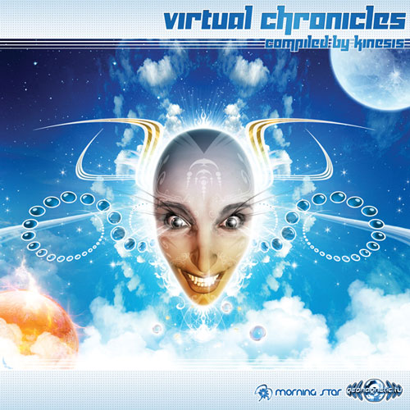 |  | RELEASE NOTES  This Hybrid collaboration Album, presented as a various artists Compilation assembled by Dj Salva (1/2 of the new French super group Crying Freemen), breaks down all barriers between the genres of psychedelic goa trance. Firmly rooted in all that’s groovy we are treated to 11 exceptional musical compositions carefully crafted by Salva at any one of his 4 studios he works in. The result is nothing short of a stellar life’s work achievement for Salva aka Kinesis for what he has created is a marvel of cinematic, emotional, sincerely touching melodic ballads that each harmonically weave together, balanced in every way. What listeners and dancers alike have expressed is a feeling of floating away to a magical dimension where all their cares and thoughts are happily enhanced by the deep hypnotic notes of each song. As a whole the composition stands on its own as an album of high quality and strong concept. As a collection of tracks djs will find that its a veritable tool chest of various styles of psytrance from feel good magical ambient through electro progressive and on to slow and funky full on then taking a step up to anthemic morning goa then back to progressive and deep trance to close with more spacey mentally awakening chill out. Each track fits together like a magical tapestry woven and carefully blended together into a continuous flowing mystical voyage through all that is virtual and back to the real world begging to go back on the fun filled memorable ride all over again. The music is easy going and straightforward enough to appeal to all fans of electronica while having many deep psychedelic layers that will keep even the most discerning and selective customers praising these stunning results! Listen for yourself, you will feel what we are communicating in the first few harmonious moments... Enjoy!  Artist Profile: http://www.myspace.com/projectkinesis  Salvador, aka Dj Salva, of Spanish origin, was born in Paris in May 1978. He got to know more about electronic music in Galicia (Spain) at an early age and he has always been keen on music, night life and preparing events. He played electric guitar and after this "rock period" he started on learning dj'ing and electronic music. Actually, he developed his dj skills quite quickly and began to mix in many Spanish clubs, thanks to 2 friends of his, a couple of techno/hardhouse dj's (Manry y Javito), who met every summer in Spain. Artists such as Infected Mushroom, Total eclipse, Astral projection, Antidote got him into fusing Nu nrg / Hard trance / Hard house, listening to Transkypet vinyl sets of DJS Olive, Seb, Randy Exess, Kid Cannonball. He discovered artists such as, Weirdo, OD404, Organ Donors BK, Nick Sentience, Lab 4 and one of his favourite djs, Mark Sinclair, who really impressed him. For his “MagicFrequency” and Nephentes parties, he always chose unusual spots and booked many dj's and artists like, Phatmatix, Silicon Sound, Triskell, Audialize, Life Extension, Naya, Olive, Seb, Ananda, Jessy, Polyphème, Psychotrop, Senix.. Salva is well known for his "dynamic" dj sets, his special technical mixing and for his "crazy versus". Salva has been involved in psytrance development for over 10 years djing, producing events and live acts. He played in Spain, France, Belgium, Chili and mainly around Paris, alongside big artists such as Jaia, Pop stream, Dado, Audialize, Silicon sound, Talamasca, Highlight-Tribe, GBU, Domestic, Bamboo Forest, GMS, Protoculture, Audiotec, DNA, Oracle, Inner Action, , Hujaboy, Scorb and many others... In spite of that, he has always wished to mix and play his own music. In 2005, he started his own music project, under the name of KINESIS. Todays, he's also working on a project with dj Naya, called CRYING FREEMEN, and with friends: CRYSTAL NETWORK and NORTHERN LIGHTS.  Label Profile:  Morningstar is a subdivision of Geomagnetic Records. Uplifting, melodic, full-on, progressive and perfect for those ecstatic moments of sunshine and awakening, the Morningstar label knows you want to be carried on a cloud of feel-good grooviness as you welcome the morning light! www.myspace.com/geomagnetic  Geomagnetic.tv was established in the summer of 2001.  Their first major international release is the legendary DVD  project “MAGNUS” geodvd001. Since then they have added 30 label artists and have multitudes of projects in the works for 2006 and beyond. Based in San Francisco and focusing mostly on visual and music related projects, you can expect to see lots more cutting edge releases on the way from this award winning crew! Geomagnetic.tv was started by Spook one of the founders of the prominent San Francisco 3D FX and Multimedia boutique known as Minds Eye Media (est.1995). www.mindseyemedia.com
Title: | Virtual Chronicles
Artist: | DJ Salva aka Kinesis+Friends
Label: | Morningstar/Geomagnetic.tv
Catalogue: | GEOCD037
Format: | 4-Panel JewelCase Audio CD
Barcode: | 881034184740
Release: | October 2008 World Wide
TRACK LIST

1- Northern Lights - Echo System
2- Crystal Network - Particles
3- Crystal Network - Elements
4- Kinesis - Global Warning
5- Crying Freemen - I Have a Dream
6- Crystal Network - Symbols are a Language
7- Kinesis - Memories
8- Kinesis - Virtual Chronicles
9- Kinesis vs Audiobrain - Defending Freedom
10- Northern Lights - Relax
11- Northern Lights - Out

CREDITS
Mastering: Mauricio@Masterizer Labs (Chile)
Artwork by Nico PsyArt - France
Distribution:SaikoSounds.com / Psyshop.com
(p) and © Geomagnetic.tv / Morningstar Rec
http://geomagnetic.tv/labels/GEO-Morningstar/GEOCD036-DjSalva-VirtualChronicles/
info@geomagnetic.tv mp3 Samples online.





