Artist Collaborative Album Enertopia - Divine – Geocd035 (GEO – ISRAEL) a Division of Geomagnetic.tv

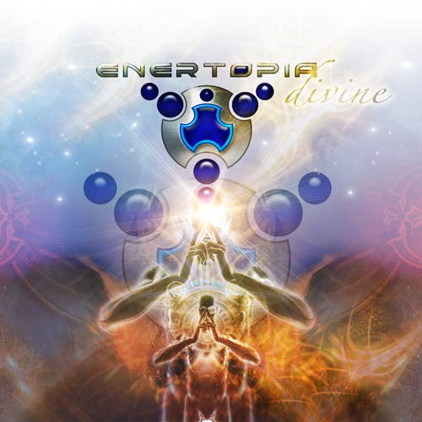 |  | RELEASE NOTES  Enertopia presents his 3rd Full Length Artist album as a smashing collaborative production featuring several top trance artists in the mix including A.P.E., Zion, Goe and more! Emiliano aka Moti fuses together the best of today’s latest innovations in psychedelic music thickly layered with the emotional and epic trance styles from his early roots in the pioneering era of goa trance. Building on his vast knowledge of technique and style acquired from over a decade of trance production this album is clearly an evolution for the genre as a whole. Emiliano (Moti) Solazzi Griminger born in Buenos Aires, moved to Israel at the age of 11 and by 18 he lead a top Israeli death metal band, CEREBRAL COMA to world wide success! In 1992, Emiliano met Ziv Matushka, another pioneer in the Israeli electronic music scene and, together, they started to experiment with more Industrial music and eventually writing Goa and Psy trance. Ziv joined P.Cok, and Emiliano continued his project as ENERTOPIA. The first single by Enertopia was released in 1996 by B.N.E Israel in a compilation called DESTINATION ISRAEL, and after a few months he was signed by KREMBO records. The first full length album was called MAGIC FOR ETERNITY, released in 1997, followed by the second album called FACE ADAPTOR which was co-written with Yuli Fershtat AKA B.L.T, Perfect Stranger .Between 1996 and 1998 along with these two hit full length albums Enertopia released numerous singles on the biggest labels in trance. Now after 3 years of hiatus Enertopia is back with new material fresh from his new state of the art studio, already collaborating with talented artists around the globe such as A.P.E from Israel, OVERDREAM from Ukraine, LOKI from Amsterdam, Aural Invasion from Denmark and more surprises to come.  Artist Profile:  Emiliano Solazzi Griminger (Moti Griminger) was born in December of 1974 in Buenos Aires, Argentina. At the age of 11 his family and him immigrated to Beer Sheva, Israel, where he lived most of his life. At the age of 15 he started to take guitar lessons and by the age of 18 he was already leading a very successful Israeli death metal band called CEREBRAL COMA, which had a mayor success in the international and national underground scene. In 1992, Emiliano hooked up with Ziv Matushka, another pioneer in the Israeli electronic music scene and, together, they started to experiment with more Industrial music and eventually writing Goa and Psy trance. Ziv joined P.Cok, and Emiliano continued his project as ENERTOPIA. The first single by Enertopia was released in 1996 by B.N.E Israel in a compilation called DESTINATION ISRAEL, and after a few months he was signed by KREMBO records. The first full length album was called MAGIC FOR ETERNITY, released in 1997, followed by the second album called FACE ADAPTOR which was co written with Yuli Fershtat AKA B.L.T, Perfect Stranger. In between 1996 and 1998 Enertopia have released two full albums and numerous singles. Now Enertopia is back with new material in the studio, already collaborating with talented artists around the globe such as A.P.E from Israel, OVERDREAM from Ukraine, LOKI from Amsterdam, Aural Invasion from Denmark. and more surprises to come. Enertopia's 3rd album "Divine" is ready and it will be released in September 2008 on Geo Israel (Geomagnetic.tv)  myspace.com/enertopiapsy | geomagnetic.tv/artists/Israel/Enertopia.htm  Label Profile: www.geomagnetic.tv  GEO-ISRAEL is a subdivision of Geomagnetic Records, offering the most cutting edge sounds from the hottest new artists of the Israeli psychedelic underground. With no distinguishing night and day, day and night, GEO-Israel offers a thick, light, full-on and dark aural journeys to enhance your trance dancing experience!  GEOmagnetic.tv was established in the summer of 2001. Based in San Francisco and focusing mostly on visual and music related projects, you can expect to see lots more cutting edge releases on the way from this award winning crew! Geomagnetic.tv was started by Spook one of the founders of the prominent San Francisco 3D FX and Multimedia boutique known as Minds Eye Media (est.1995). www.mindseyemedia.com
Title: | Divine
Artist: | Enertopia and Friends
Label: | Geo - Israel
Catalogue: | GEOCD035
Format: | 6-Panel Jewel Case Audio CD
Barcode: | 881034184733
Release: | September 2008 World Wide
TRACK LIST

1. Enertopia vs Aural Invasion-Electric Nataraja
2. GOE-Jupiter Beach (Enertopia Remix)
3. Enertopia vs Zion vs Loki-Rats on the run (SMS Remix)
4. Enertopia - Shadow World (Album Version)
5. Enertopia - Heofonrices Weard
6. Zion-Memory Break (Enertopia Remix)
7. Enertopia - Shadow World (Loki Remix)
8. Enertopia vs Overdream vs Loki - Furian Cells
9. A.P.E vs Enertopia - The Bright Triangle (Enertopia RMX)

CREDITS
Mastered in Israel
Artwork by www.Spaceshirt.ch
Distribution: Saikosounds, Psyshop, Geomagnetic.tv
(p) and © GEO - ISRAEL (a division of Geomagnetic Records)
info@geomagnetic.tv Hi-Res art online:
http://geomagnetic.tv/labels/GEO-Israel/GEOCD035-Enertopia-Divine




