JIRAH aka Tim McCall - “Journeys” CD – geocd037 Geo-Morningstar (Geomagnetic.tv)

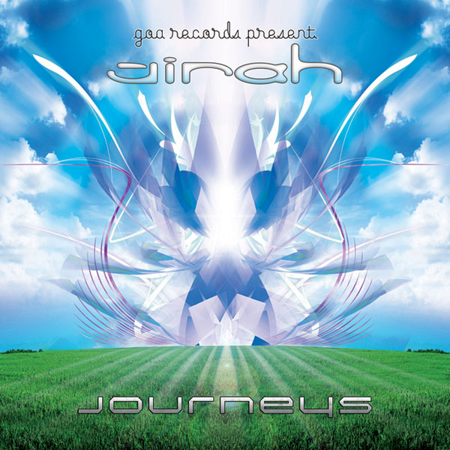 |  | RELEASE NOTES  Journeys is the 2nd full length album for Jirah aka Tim McCall who is firmly regarded as the premiere full on/progressive GOA psytrance producer to emerge in the past decade from the USA, a place that is more and more being regarded with awe and respect for providing the world with some of the leading psychedelic music makers from this tightly knit global community. After taking 3 years off to focus on his family (yes he is married with a newborn!) Tim has polished off the best of his most heartfelt and truly memorable musical productions and with the masterful assistance of Random aka Ross Dubois engineered each track to a new level of perfection using the state of the art production facilities at world famous geomagnetic headquarters in San Francisco. The world has been literally begging for this album to be released and to answer the pleading fans around the world we have lovingly crafted a memorable and highly professional presentation of Tim's work that will be cherished by the fortunate ones to purchase one of these limited edition collectors’ items. The Jirah project has been elevating dance floors since before the turn of the millennium giving Tim an unparalleled level of wisdom and experience when it comes to crafting epic music. His style blends deep melodic bass lines with anthemic and uplifting hooks combined with smooth and tasteful arrangement showing his truly master level musical skills and production values in sound engineering. Jirah’s music has appeared on over 20 compilations from the most respected labels in trance. His 1st album on USTA (Israel) sold out (3000 units) in under 6 months. Look out for what could easily be the biggest surprise hit of the summer of 2008!  Artist Profile:  Tim McCall (Jirah) is known for creating energetic and atmospheric trance music, although the Jirah name has occasionally been associated with a more downtempo style. Coming from a musical family, he learned many instruments, his favorite being guitar. He grew up listening to a mix of rock and early techno music, experimenting with digital processing from the age of 12. His first exposure to goa/psy music came with the release of the "Blue Room / Trip Through Sound" compilation in 1997, which set him on a direct course into producing this type of sound. It was during this time that Jirah was born, and over the years Tim's music evolved as he continued to refine his skills. His debut album was released in 2003 on USTA Records, receiving strong reviews and acclaim worldwide. Tim went on to release music on many other labels such as Dragonfly, Aleph Zero, Organic, Harmonia and Spliff to name a few. Since his first live show in 2001, he has played throughout the world, from Europe to Asia to the Americas. In 2005, due to a mixed set of circumstances, Tim decided that he needed to take a break from songwriting and performance. His music continued to be released during this time, and after a three year silence, he is back on the scene with new projects on the way. Stay tuned for information on new artistic directions and of course, new music!  www.myspace.com/timmccall2 | www.geomagnetic.tv/artists/Jirah.htm  Label Profile:  Morningstar is a subdivision of Geomagnetic Records. Uplifting, melodic, full-on, progressive and perfect for those ecstatic moments of sunshine and awakening, the Morningstar label knows you want to be carried on a cloud of feel-good grooviness as you welcome the morning light! www.myspace.com/geomagnetic  Geomagnetic.tv was established in the summer of 2001.  Their first major international release is the legendary DVD  project “MAGNUS” geodvd001. Since then they have added 30 label artists and have multitudes of projects in the works for 2006 and beyond. Based in San Francisco and focusing mostly on visual and music related projects, you can expect to see lots more cutting edge releases on the way from this award winning crew! Geomagnetic.tv was started by Spook one of the founders of the prominent San Francisco 3D FX and Multimedia boutique known as Minds Eye Media (est.1995). www.mindseyemedia.com
Title: | Jirah aka Tim McCall - Journeys
Artist: | JIRAH aka Tim McCall
Label: | Morningstar/Geomagnetic.tv
Catalogue: | GEOCD037
Format: | 4-Panel JewelCase Audio CD
Barcode: | 881034098542
Release: | October 2008 World Wide
TRACK LIST

01-A Pure Moment
02-The Next Step
03-Nice Bytes
04-Inner Process
05-Durenan
06-Contact
07-The Only Constant-rmx
08-Virtual Vortex
09-Nilandra
10-Psyrene

CREDITS
Mastered by Random @ Geomagnetic
Artwork:Jose Luis Raso keelimanitu@hotmail.com
Distribution:SaikoSounds.com / Psyshop.com
(p) and © Geomagnetic.tv / Morningstar Rec
http://geomagnetic.tv/labels/GEO-Morningstar/GEOCD037-Jirah-Journeys/
info@geomagnetic.tv mp3 Samples online.





