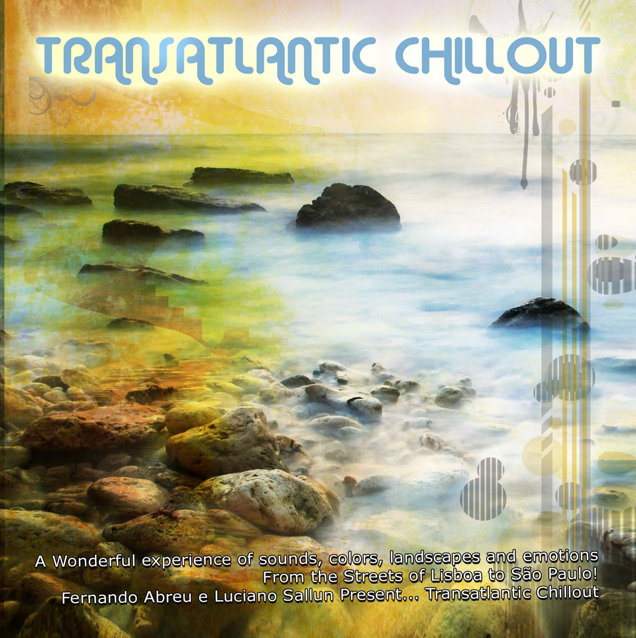
Hearts Eye Records
San Francisco
CA, 94133, USA

Title: Transatlantic Chillout, Compiled by Fernando Abreu & Luciano Sallun

Artist: Various
UPC #: 881034279125
Catalog: Hercd004
Contact: info@saikosounds.com

Tracklisting:

1. Ambiens Indages - Conto dub II
2. Baque in Beat - Maré Sintética
3. Teresa Gabiel & Ambiens Indages - Caravela Sideral Azul
4. Pedra Branca - Berimbau Groove
5. Yubaba - Sunset over Lisbon
6. Balancé - Rockbill
7. Global Project - Lowbeat Science
8. Sérgio Walgood - The Dream
9. Smiley Pixie - A new beginning
10. Shakri - Ancestral Voice

About:

The concept of this chillout compilation is to unite Portuguese and Brazilian music without any borders or frontiers. Creating a edition available to everyone, worldwide in multiple formats exploring multiple directions and styles. Fernando Abreu and Luciano Sallun gently gathered this finest selection of sounds and positive energies. Fernando and Luciano are two very important artist recognized by their talent, innovating work and beautiful chillout music! They bring to you, Transatlantic Chillout, a wonderful experience of sounds, colors, landscapes and emotions... From the urban to tribal, electronic to primal from the streets of Lisboa to São Paulo… This amazing compilation features the finest chill out artists: Pedra Branca,Teresa Gabriel, Smiley Pixie, Shakri, Ambiens Indages, Sérgio Walgood, Baque in Beat...and many others! This is the first part of the Transatlantic Journey. Mastering & Design: Fernando Hood Abreu @ Smiley Pixie Studios

Label: Hearts Eye Records was founded in 2006 by Rob Rayle, long time figure head and founder of several pivotal electronic music collectives in the San Francisco Bay Area. His professional music career has taken off and enabled the label to prosper as a platform for international downtempo and ambient artists.

