GOA Trance Missions v2 Night gtm002n - V/A DJ Mix by Goa Doc aka Dr Spook – (GOA REC)

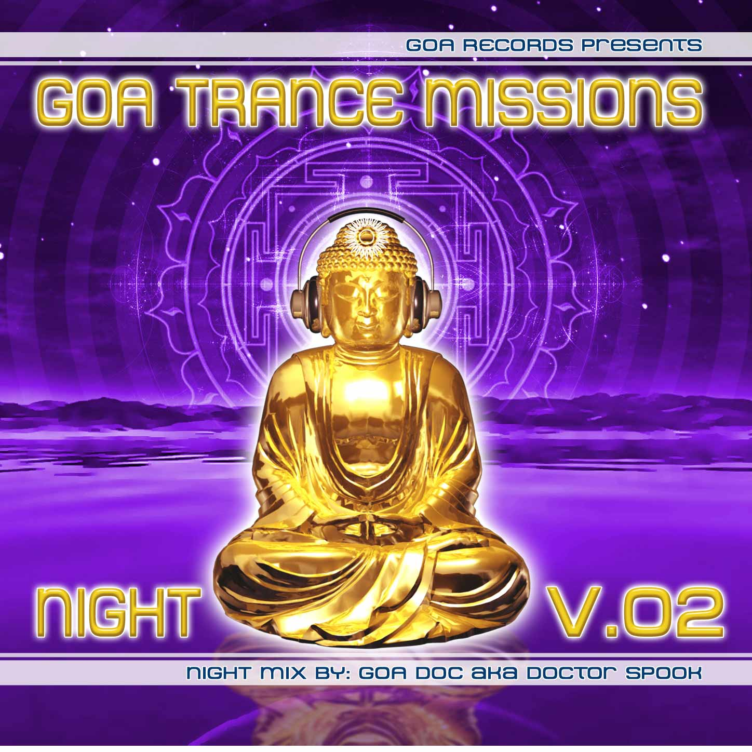 |  | RELEASE NOTES: Goa Trance Missions Vol. 2 Night  The best of Goa Trance hits collection from the Master of Goa Trance DJ Goa Doc. This perfectly balanced set of Goa beach party psytrance gems features dreamy melodic songs, next to full power high-energy Electronic Dance favorites. GOA Trance Missions features the best in Goa trance music fresh from the hottest artists around the world! This new epic music series contains a wide variety of CD and DVD dance party DJ mix compilations by Goa Doc (aka Doctor Spook) one of the top Goa DJ’s spinning today. Memorable samples, heartfelt melodic hooks, full power raging bass lines, original compositions and fresh sounds, fill this CD series from the hottest new trance musicians around the world who have been growing their styles on local dance floors across the planet. These dynamic elements all combine to create the perfect refreshing musical dose of life bliss that will make you scream for more while dancing uncontrollably. This CD contains a cross section of the best Goa music featuring the top masters and new wizards of Goa Trance (aka Psychedelic Techno, Hard Dance, Progressive Tech House), offering a real world glimpse into the magic and mystery that is felt each weekend at the parties all over the world. People gather to dance to this uplifting music in the biggest clubs, as well as the classic secret parties around the planet, held on beaches, forests, mountain tops, deserts, community halls, warehouses, yoga/dance studios, and living rooms. The broadly defined genre of Goa trance is a favorite at the worlds largest festivals such as Boom, Burning Man, Universo Parrello, Full Moon, Voov Experience, The Love Parade, Earthdance, The Ultra Music Festival, and countless others. Now you can have your own taste of this worldwide EDM (electronig dance music) phenomena and relive the excitement that this inspiring experience conveys. Welcome to your own personal Goa Trance Mission! Looking for a mind - blowing visual dance experience to go with your music? Need some psychedelic visuals from the world’s top VJ’s? Check out the brand new DVD VJ Mix series “Goa Trance Visions VJ Party Mix On A Disc.” Play it on your TV or video projector to create an instant party atmosphere, that goes with the music, featuring stunning 3D animated visuals, film clips and mix graphics from leading world animators and filmmakers.  For more information on new releases please visit our website at www.goa-records.com .  Artist Profile:  Goa Doc (aka DJ/VJ Doctor Spook & Nathan Vogel) from San Francisco is a world renowned DJ/VJ, award winning 3D animator and music video director. He began creating psychedelic visuals and music in 1992 and has been receiving critical acclaim for all of his projects with Minds Eye Media. Spook has worked with many major music labels such as Arista, Geffen, Universal, Sony, Om, Spun and other prominent global Psy - trance labels to introduce ground breaking hot new releases. Spook’s passion for electronic music drove him to start making music in 1990 as Mindstorm. He began DJing psytrance at the Burning Man festival in 1998. Doctor Spook now tours the world every year playing at festivals such as Bonaroo, Boom, Burning Man, The Love Parade, Earthdance and many others.  Label Profile:  Goa Records is a new label founded in 2006 based in California/USA. Focused on finding the very best of the worlds leading psy-trance and goa-trance hits and compiling these into a highly commercialized package suitable for mainstream distribution outlets. Expect a steady stream of high quality, cutting edge releases from this already amazingly popular new label.
Title: | Goa Trance Missions Vol. 2 Night
Artist: | V/a by Goa Doc aka Dr. Spook
Label: | Goa Records
Catalogue: | GOAGTV002n
Format: | 4-Panel Jewel Case Audio CD
Barcode: | 881034378163
Release: | June 2009
TRACK LIST

01 - Random - Bifurcation - 147
02 - Tsabeat - Electrical Activity - 146
03 - Paraforce - Slave Of the Lord - 148
04 - DarkForce - Darkness and the Spirit - 150
05 - Electrypnose vs Elendil vs Zapata - Des Trip Laids - 148
06 - Vectro Electro - Monster Bash - 148
07 - Bodhisattva 13:20 aka Bodhi - Gravitron Deflector - 146
08 - Mubali vs Arahat aka Arabali - Lunar Freqs - 145
09 - Onnomon - Virtual God - 135
10 - Deeper In Zen - Anicca - 143
11 - Psychoz vs Sofia - X - Chicken Virus - 149

CREDITS:
Artwork by: Doctor Spook
Compiled By: Goa Doc aka Doctor Spook
Distribution by Saiko Sounds and Geomagnetic Rec.
(p) and © Goa Records + Geomagnetic.tv
www.goa-records.com www.geomagnetic.tv
info@geomagnetic.tv More info online.



