TeTuna – Psychedelic Transition – GOAREC011 – Goa Records

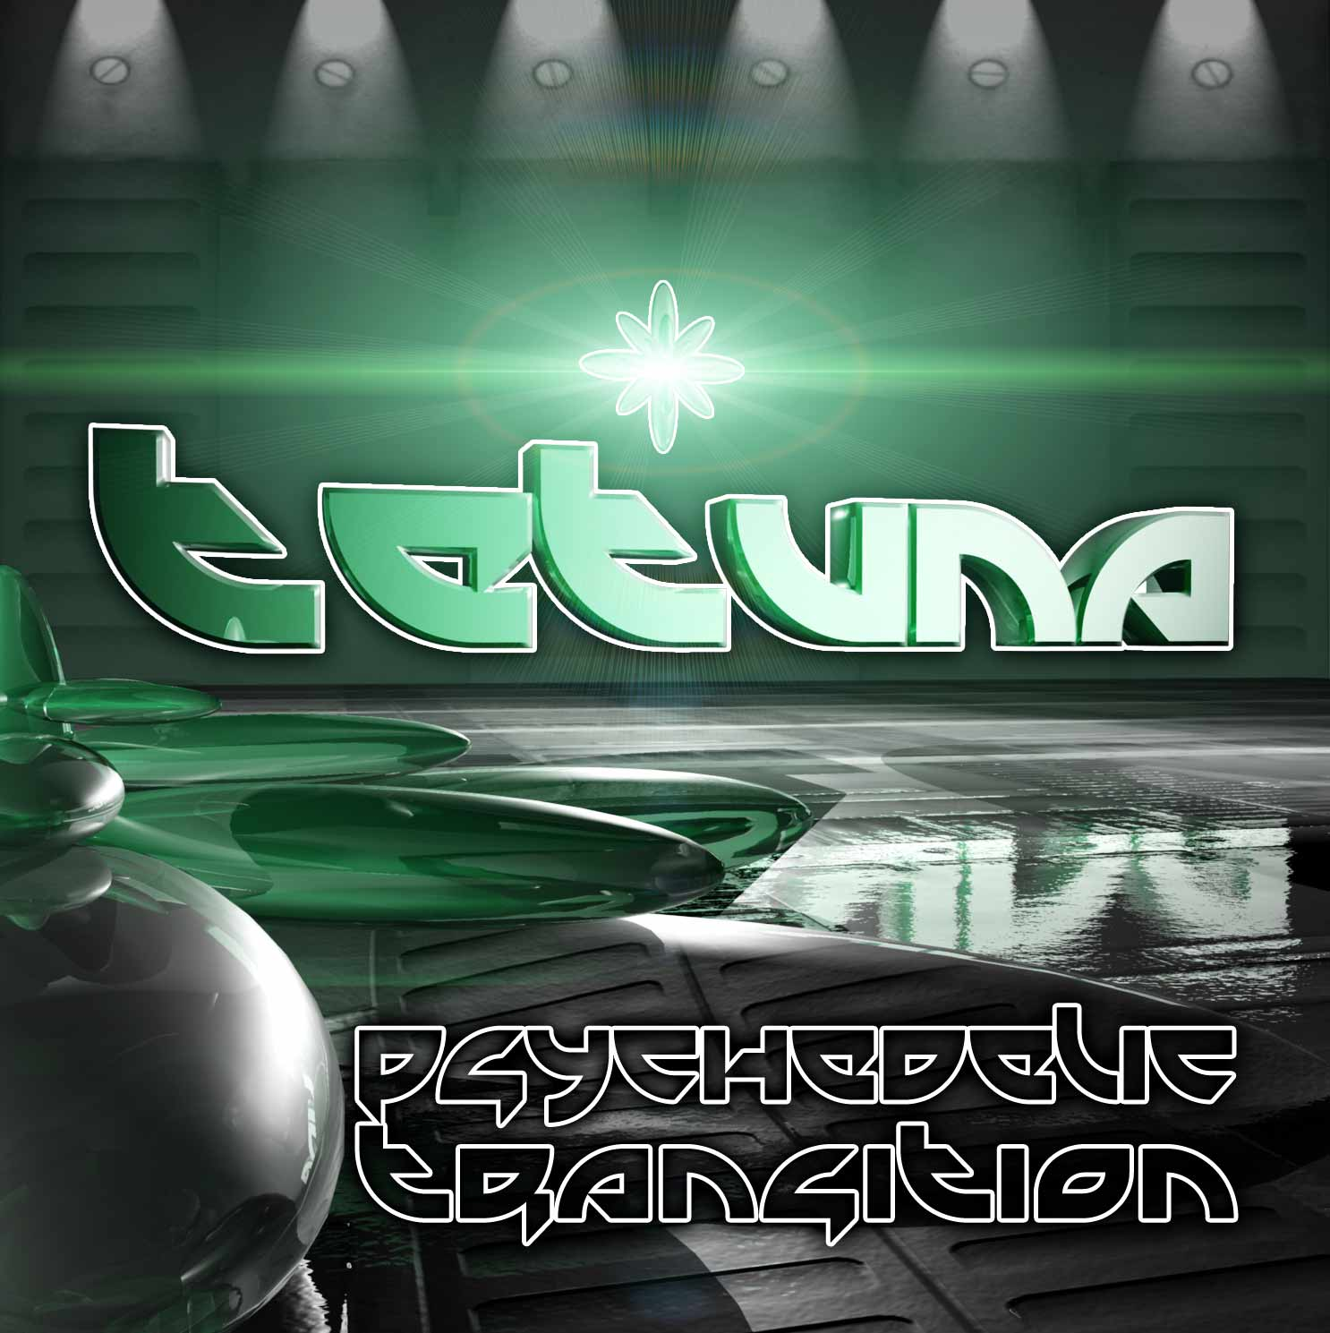 |  | RELEASE NOTES:  TeTuna – Psychedelic Transition – GOAREC011  Goa Records is proud to present the long awaited debut album of French psytrance virtuoso, TeTuna. This Uplifting approach to the full on genre is a breath of fresh air that stands out as a pure and pristine offering of truly inspired dance music. Each track touches the listener’s heart and soul with the feeling of happy and care free times. Te-Tuna, premier Trance producer from France is aka Damien Papot aka dj Dam, part of psy-org Phoenix Frequencies (France) and Geomagnetic.tv (San Francisco - USA). He discovered psy trance in 1996 by listening to a goa and ambient radio show “Take Off” presented by dj Pulsate/Signs who also collaborated with TeTuna on hit track the “Ancient Flying Technologies”) and dj M-Rik from “Moon Spirits rec.” Then, Dam was added to the team more than 5 years ago and played dj sets on radio and parties. He started his own project and began to produce tracks with his musical knowledge. Now Dam’s is producing morning but resolutely dancefloor psytrance tracks in his studio - sometimes with friends - finishing debut album on Geomagnetic and playing constantly in parties around the world with the same spirit: for the people dancing and dreaming! Recently he’s took the 2nd place in the “Cytopia Artist Competition” with his tune “Halissa”, out soon on Goa-Cytopia V/A – Stay in touch!  Artist Profile: myspace.com/tetuna  Label Profile: myspace.com/geomagnetic  Goa Records is a new label founded in 2006 based in California/USA. Focused on finding the very best of the worlds leading psy-trance and goa-trance hits and compiling these into a highly commercialized package suitable for mainstream distribution outlets. Expect a steady stream of high quality, cutting edge releases from this already amazingly popular new label.  GEO-MorningStar Morningstar is a subdivision of Geomagnetic Records. Uplifting, melodic, full-on, progressive and perfect for those ecstatic moments of sunshine and awakening, the Morningstar label knows you want to be carried on a cloud of feel-good grooviness as you welcome the morning light! www.myspace.com/geomagnetic  Geomagnetic.tv was established in the summer of 2001 by Dr. Spook one of the founders of the prominent San Francisco 3D FX and Multimedia boutique known as Minds Eye Media (est.1995). www.mindseyemedia.com
Title: | Psychedelic Transition
Artist: | TeTuna
Label: | Goa Records
Catalogue: | GOAREC0111
Format: | 4 Panel Insert Jewel CD / DDL
Barcode: | 881034378002
Release: | August 2009
TRACK LIST

01-TeTuna - LSD 138
02-TeTuna - Crop circles 140
03-TeTuna - Baby's Return 142
04-TeTuna - Hot Stuf 142
05-TeTuna - Wonders Touch 145
06-TeTuna - Madstreet 142
07-TeTuna - Positive world 145
08-TeTuna - Sparring program 146
09-Virtual Light - Nuclear Sun (TeTuna Rmx) 145
10-TeTuna - Dahilalaoh 120

----------------------------------------------------------

CREDITS:
Music W&P by: Damien Papot aka Tetuna
Album graphics: Dr. Spook
Distribution: Geomagnetic, Saikosounds.com, Goa-Records.com
(p) and © www.Geomagnetic.tv
info@geomagnetic.tv
http://geomagnetic.tv/news/goarec011


