NOV SANUS - “Waves Of The Dreamworld” basscd006 CD – Bass-Star Rec (Geomagnetic.tv)

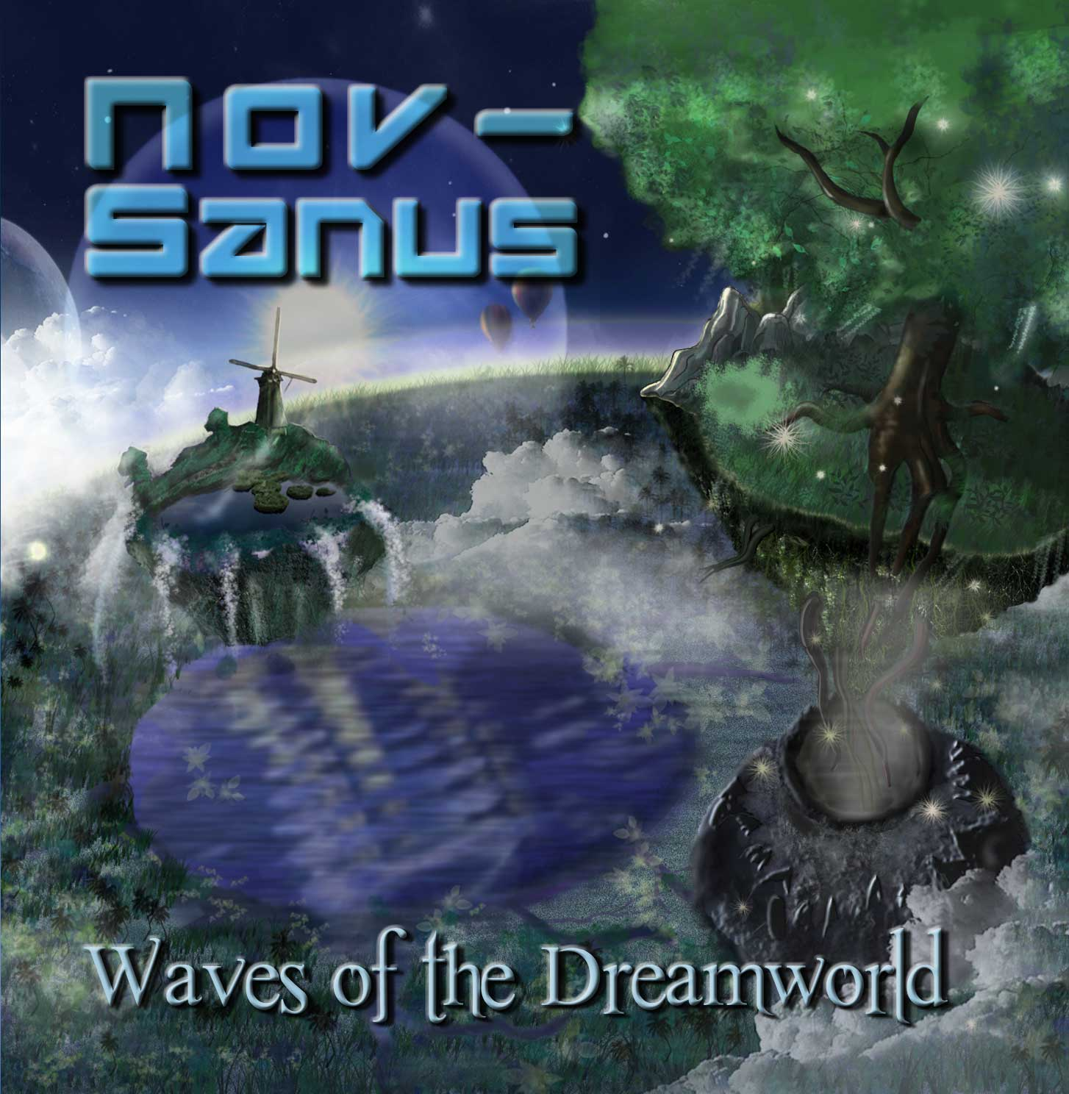 |  | RELEASE NOTES  The debut album from Nov-Sanus (Joe Schaeffer, San Francisco/USA) aka Digital Space is a journey through the tangled synapses of the subconscious. The album flows from one track to the next with a wobbly, hypnotic swagger through the shifting canvas of a dream. A variety of different genres fuse to make a juxtaposed soup of beats. Organic and synthetic sounds mix to put a new spin on the psychedelic spectrum. So relax! This is music to dance like nobody is watching. For the past 10 years Joe Schaeffer has been perfecting his sound working in the studio and playing parties around Northern California. A few years ago he set out to create music with slower tempos that could hypnotize and move the audience. Waves of the Dreamworld is the fruition of several years of writing, playing out, and experiencing great psychedelic music. So close your eyes, crank up your sound system and see what visions come from this album!  “Expect moments that remind you of the best parts of Sphongle’s first album and then start going up from there…” – Mindstorm  Artist Profile  Joe Schaeffer has been creating electronic music for years and has recently shifted gears toward a more experimental style of music. This new style is intended to take you away and open your mind. A psychedelic journey through various styles and genres with the mood/feel of Sphongle, Androcell, Slack Baba, and Ott. Pushing the envelope of psychedelic progression. A juxtaposed audio phonic soup where new psychedelic sounds can be savoured.  More info and downloads: www.spacebeats.com | www.geomagnetic.tv/artists/nov-sanus.htm | www.myspace.com/novsanus  BasStar Records formed in summer of 2007 and is focused primarily on breaks, dub step, electro house and down tekno grooves. Expect lots of wild unpredictable new cuts coming from this phatty side project from Geomagnetic Records Label Group.  Geomagnetic.tv www.geomagnetic.tv was established in the summer of 2001. Their first major international release is the legendary DVD project “MAGNUS” geodvd001. Since then they have added 30 label artists and have multitudes of projects in the works for 2006 and beyond. Based in San Francisco and focusing mostly on visual and music related projects, you can expect to see lots more cutting edge releases on the way from this award winning crew! Geomagnetic.tv was started by Spook one of the founders of the prominent San Francisco 3D FX and Multimedia boutique known as Minds Eye Media (est.1995). www.mindseyemedia.com
Title: | Waves of The Dreamworld
Artist: | Nov Sanus
Label: | BasStar/Geomagnetic.tv
Catalogue: | BASSCD006
Format: | 6 Panel Jewel Case Audio CD
Barcode: | 881034278937
Release: | July 2009 World Wide
TRACK LIST

1. Intro
2. Pandora’s Box
3. Forgotton Ages
4. Silent Voice
5. Morphing Mindstates
6. Formless State
7. Life Cycle (Part II)
8. Origin
9. It
10. Fire Dancer

CREDITS
Mastering: Kevin Pooler (Canada) @ www.Redcouchrecordings.com
Artwork: Kiyomi & Satoshi (sato4art@gmail.com)
Distribution by SaikoSounds / Geomagnetic Records
(p) and © Geomagnetic.tv
info@geomagnetic.tv
Hi-Res art online.


