Ectima aka Zyce & Flegma - “No Way Out” CD – geocd038 Geo-Morningstar (Geomagnetic.tv)

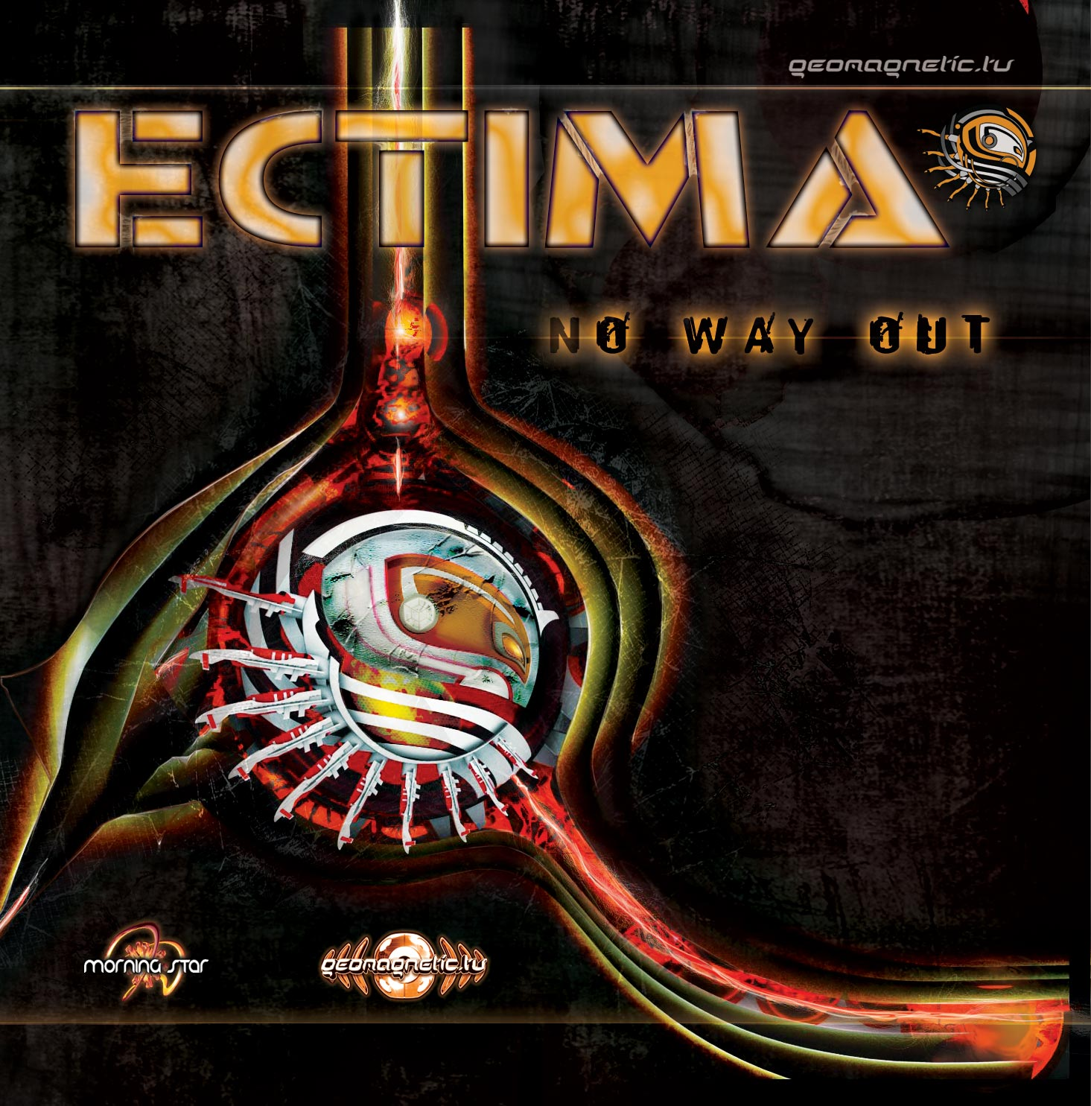 |  | RELEASE NOTES  Ectima is a progressive tech-trance project created by Dalibor Delic aka Flegma and Nikola Kozic aka Zyce. This sensational new project has put their best inspiration together for this truly original new album “NO WAY OUT”, consisting of 10 tracks of pure “technotic” madness, infused with hard basslines, twisted electric leads and complex fx works, all arranged in extraordinary way which is constantly developing into new and original sound forms that represent a true innovation. Constant sound-shifting, dynamic breaks and changes of rhythmic patterns will definitely cause some hard sonic explosions and weird seismic activities. Hypnotic progression will take you into intelligently structured labyrinth of sounds; your mind will be open and senses aware that anything can happen. Live acts are characterized with highly energetic intense tracks with unusual drum loops and uplifting breaks, with wide and clean production, which is their trademark. While listening to it over and over, it takes you deeper and deeper, until you finally realize that there is no way out.....  Ectima is a progressive tech trance project created by Dalibor Delic and Nikola Kozic. The dynamic duo started their collaboration in the year 2004. Since early days Nikola aka Zyce was interested in music, with experience playing in numerous rock, reggae and metal bends. After years of playing Nikola found himself in Electronic music and started creating his recognizable progressive style. Nikola utilizes his vast musical knowledge in a variety of instruments such as the Keyboard, Guitar, Bass Guitar and Drums to name a few. In June 2008 he released a collaboration album Zyce & Fox for Synergetic Records. Dalibor aka Flegma was producing all kinds of beats, writing melodies and arranging songs, using gadgets and synths that was available. He began to learn about music at early age, influenced by his older brother who play bass and guitar. He grew up listening a music with a lot of different influences until the 1999 when trance music hit him so hard, that he knew it was his calling where he could express his ideas through electronic music production. Aside from signed Iono Music, Zyce and Flegma releasing tracks for Synergetic records, Spin Twist records, YSE... At the moment Flegma is preparing a collaboration album with Nerso which is about to be released this year. Ectima already has unique progressive tech trance style, which gained very positive feedback from the audience after few live performances.Their sound can be defined as a mixture of deep bass lines, strong percussive sequences, dark pads and eletric fx's synth arranged in extraordinary way which is constantly developing into new and original sound forms that represent a true innovation. Live acts are characterized with highly energetic intense tracks with unusual drum loops and uplifting breaks, with wide and clean production, which is their trademark.  Label Profile:  Morningstar is a subdivision of Geomagnetic Records. Uplifting, melodic, full-on, progressive and perfect for those ecstatic moments of sunshine and awakening, the Morningstar label knows you want to be carried on a cloud of feel-good grooviness as you welcome the morning light! www.myspace.com/geomagnetic  Geomagnetic.tv was established in the summer of 2001. Their first major international release is the legendary DVD project “MAGNUS” geodvd001. Since then they have added many new and established international label artists and have a steady stream of amazing top quality releases. Based in San Francisco and focusing mostly on visual and music related projects, you can expect to see lots more cutting edge releases on the way from this award winning crew! Geomagnetic.tv was started by Spook one of the founders of the prominent San Francisco 3D FX and Multimedia boutique known as Minds Eye Media (est.1995). www.mindseyemedia.com | www.geomagnetic.tv
Title: | Ectima – No Way Out
Artist: | Ectima aka Zyce & Flegma
Label: | Morningstar/Geomagnetic.tv
Catalogue: | GEOCD038
Format: | 4-Panel JewelCase Audio CD
Barcode: | 881034278968
Release: | March 2009 World Wide
TRACK LIST

01.Ectima - Find The Way Out
02.Ectima - Logatone
03.Ectima - Evil Spirits
04.Ectima - Labyrinth
05.Ectima - Black Humor
06.Ectima & PhaseTech - Spliced
07.Ectima - Metal Isolation (rmx)
08.Ectima - Home Treatment
09.Ectima - Insufferable User
10.Talpa - Sleeping Beauty (Ectima rmx)

CREDITS
Mastered by Zyce + Flegma @ Tesseract
Artwork:Tesseract Studios
Distribution:SaikoSounds.com / Psyshop.com
(p) and © Geomagnetic.tv / Morningstar Rec
http://geomagnetic.tv/labels/GEO-Morningstar/GEOCD038-Ectima-NoWayOut/
info@geomagnetic.tv mp3 Samples online.



