v/a Piloted by Doctor Spook –“Fed-X – Next Day X press” CD– [geocd045] Morningstar (Geomagnetic.tv)

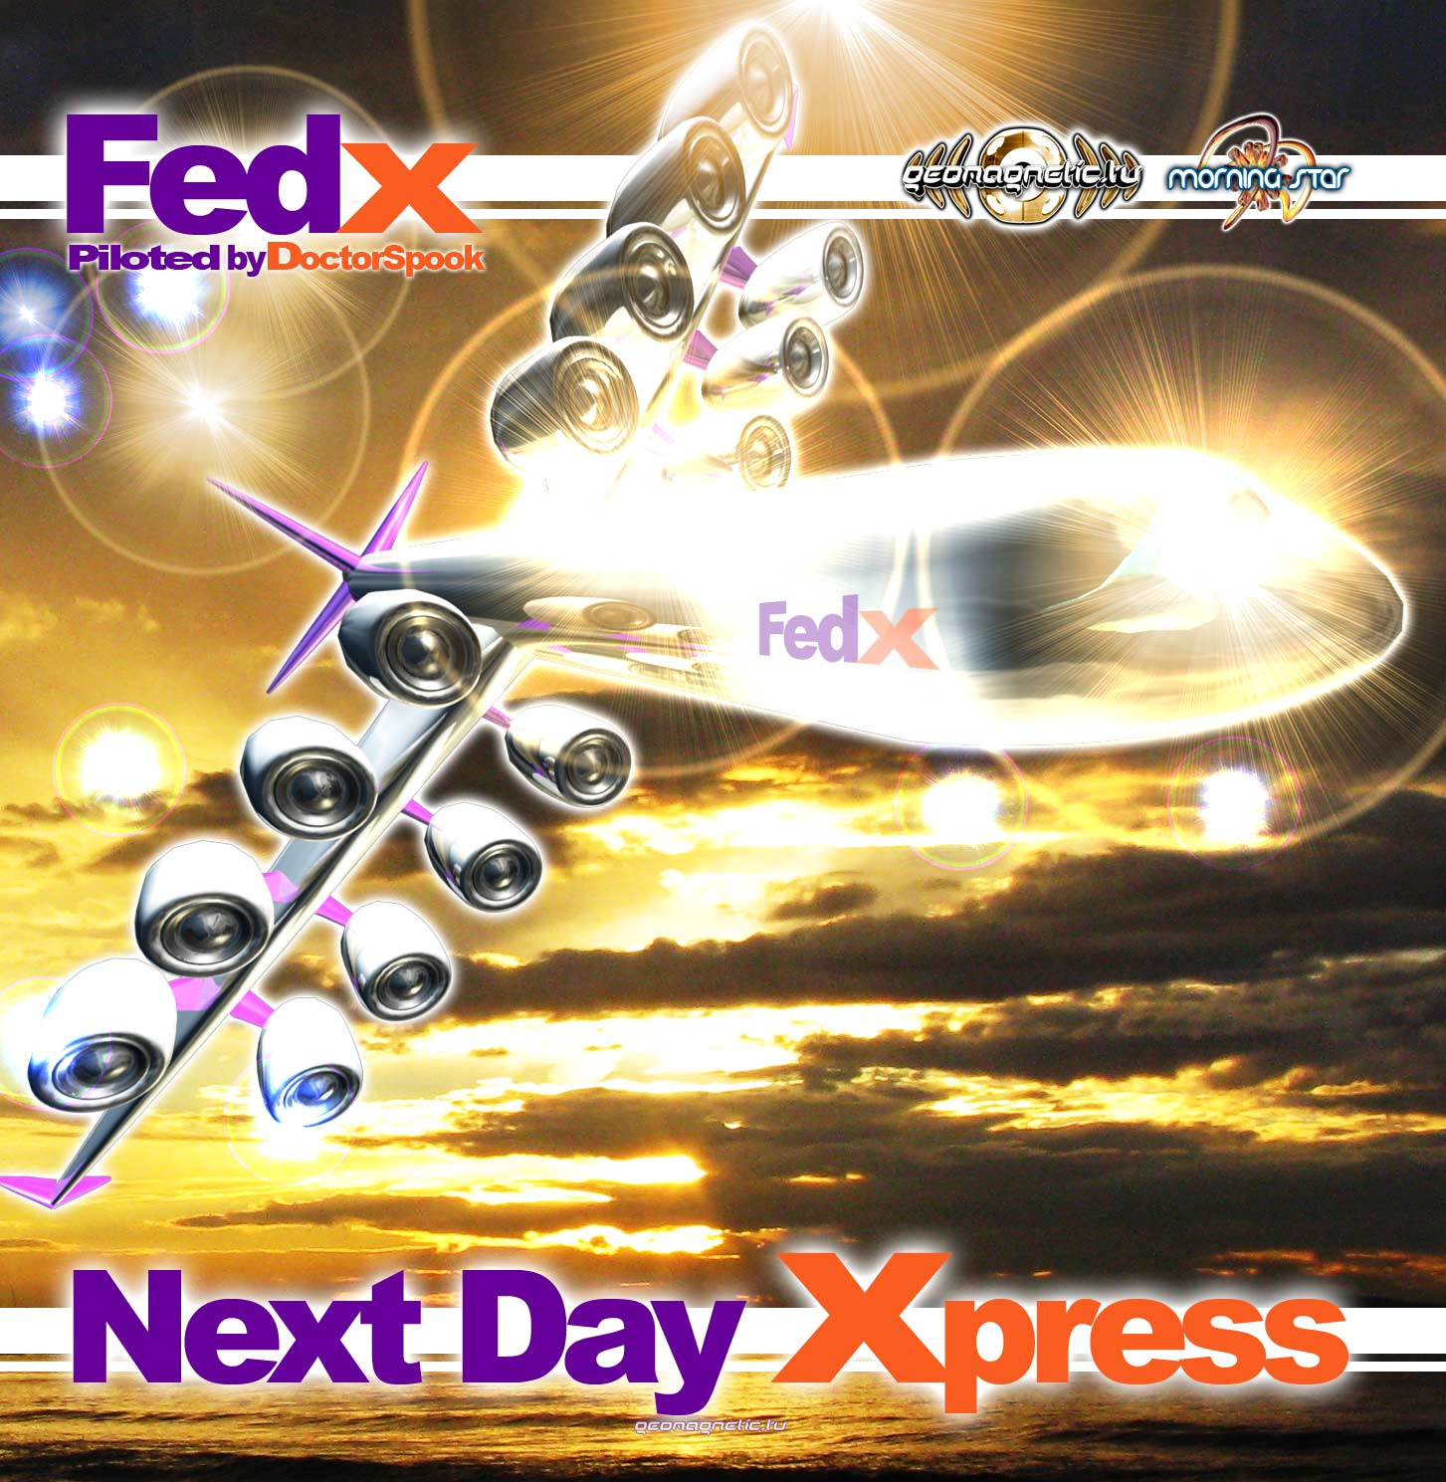 |  | RELEASE NOTES  Fed - X: Next Day X press ...Imagine you are the co-Pilot of an interstellar X press delivery trance-port with important destinations across the galaxy for a Next Day X press round trip. This trip seems to take off smoothly but once airborne you realize there was an unexpected stowaway who got on board the private party ship. Le SHEITAN himself makes a guest appearance! Suddenly everyone is FALLING INTO THE DARKNESS on what might end up being a one way trip! Everyone on the dance floor freaks out as they realize they have a BRAIN PARASITE! You begin having irrational impulses until the ships computer kicks in and gives everyone a NIGHTSHOT. When the dancefloor frenzy recovers the captain announces that we had an encounter with THEE OLDE ONES. After the BROKEN TENSION everyone settles in to the journey. The autopilot shares the story of THE PROPHECEY that tells of the power within through following your bliss your can achieve enlightenment. IT IS LIFE’s purpose to do what you most feel drawn to do, your higher purpose. SO LETS GO and make your dreams become reality by committing to doing your calling with each passing day. OPEN YOUR EYES and realize that your realizations you had on your journey are important! Integrate them into your life! The pilot announces that your ships auto pilot is set to safely guide you home where you will soon be ready for another adventure on the intergalactic FED - X – NEXT DAY X-PRESS. Doctor Spook pilots the way once again on another space voyage full of fresh new unreleased treats for your mind, body and soul. Oodles of Hits from well known master trance artists as well as a healthy Dose of new comers with surprisingly amazing new sounds from across the globe and beyond. Featuring 10 world class international psytrance masters of their art: Axeone vs TeTuna (France), Hypohektika aka Dnoiser (Germany/USA), 01N(Japan), Bratex(Brazil), FrostRAVEN (USA), Micro Scan (France), Kinesis (France/Spain), Imix (Austria), Skyloops (Argentina) and Aya (Canada).  Artist Profile: http://www.myspace.com/mindstorm1  Doctor Spook (Mindstorm) MINDSTORM (aka Nathan Vogel aka Doctor Spook) has morphed into an amazing LIVE VISUALS AND MUSIC project that Doctor Spook has been realizing from the SAN FRANCISCO based GEOMAGNETIC World Headquarters. Musically Spook is collaborating with a stream of the worlds leading musical masterminds inlcuding Tamir Ozana from Atomic Pulse, Chromatone and Random, Altom, Earthling, Central Processing Unit & Twisted Reaction Mindstorm has a strong concept with each track, a detail lacking in much of todays dance music.  Label Profile:  Morningstar is a subdivision of Geomagnetic Records. Uplifting, melodic, full-on, progressive and perfect for those ecstatic moments of sunshine and awakening, the Morningstar label knows you want to be carried on a cloud of feel-good grooviness as you welcome the morning light! www.myspace.com/geomagnetic  Geomagnetic.tv was established in the summer of 2001.  Their first major international release is the legendary DVD  project “MAGNUS” geodvd001. Since then they have added 30 label artists and have multitudes of projects in the works for 2006 and beyond. Based in San Francisco and focusing mostly on visual and music related projects, you can expect to see lots more cutting edge releases on the way from this award winning crew! Geomagnetic.tv was started by Spook one of the founders of the prominent San Francisco 3D FX and Multimedia boutique known as Minds Eye Media (est.1995). www.mindseyemedia.com  
Title: | Fed X – Overnight X press
Artist: | Va piloted by Doctor Spook
Label: | Morningstar/Geomagnetic.tv
Catalogue: | GEOCD045
Format: | 6-Panel JewelCase Audio CD
Barcode: | 881034279071
Release: | December 2008 World Wide
TRACK LIST

01-Axone vs TeTuna- Sheitan
02-Hypohektika aka dnoiser-Falling Into The Darkness
03-01N-Brain Parasite
04-Bratex-Nightshot
05-FrostRAVEN-Thee Olde Ones
06-Micro Scan-Broken Tension
07-Kinesis-The Prophecy
08-Imix-It Is Life
09-Skyloops-Let's Go
10-Aya-Open Your Eyes

CREDITS

Mastering: Sidhartha (Portugal)
Artwork by: Doctor Spook - SanFrancisco
Distribution:SaikoSounds.com / Psyshop.com
(p) and © Geomagnetic.tv / Morningstar Rec
http://geomagnetic.tv/labels/GEO-Morningstar/GEOCD045-FedX-NextDayXpress
info@geomagnetic.tv mp3 Samples online.



