DIGITAL DRUGS: DOUBLE THE DOSE - V/A geocd016
2 CD Set Compiled by Doctor Spook – DARKSTAR / Geomagnetic.tv

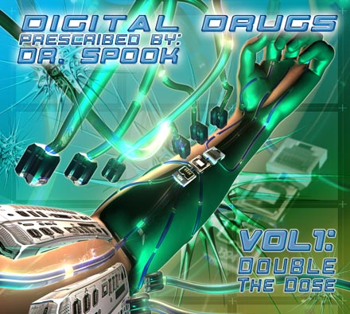 |  | RELEASE NOTES  Doctor Spook prescribes a carefully calculated dose of the most cutting edge sounds and full power psychedelic mayhem in the form of a mind blowing 2 CD Compilation. This collection is designed to take you on a journey both into and out of your mind… and beyond! So gather your favorite interface methods and plug in for a 160 min voyage through DIGITAL DRUGS.  Tons of fresh new talent combined with the proven skills of such masters as: Bus, Electrypnose, and Mubali. Artists from around the world have combined their unique ingredients to concoct a fabulous formula the likes of which no one has ever experienced! Several new geo - label artists proudly debut their work including: Facehead (USA), Neuromyth (Canada) as well as Airi vs Fabiuz (Germany) and lots more… expect lots more crazy goodness coming from GEOMAGNETIC DARKSTAR in a steady stream of demented hits!  Artist Profile:  DJ/VJ Doctor Spook (San Francisco, USA)  Also known as Nathan Vogel, Spook is an award winning  3D animator and music video director. He began creating  psychedelic visuals in 1992, receiving critical acclaim for  all of his projects. Nathan has worked with major music labels such as Arista, Geffen/Universal, Sony, Om and now with all of the most prominent Psy-trance labels with ground breaking new releases. Spooks passion for electronic music drove him to start making music in 1990. He began DJing Psy-trance at the Burning Man festival in 1998.  Label Profile:  Darkstar is the sub-label of Geomagnetic that focuses on Dark, Night time music, with hard and experimental styles.  Geomagnetic.tv was established in the summer of 2001.  Their first major international release is the legendary DVD  project “MAGNUS” geodvd001. Since then they have added 30 label artists and have multitudes of projects in the works for 2006 and beyond. Based in San Francisco  and focusing mostly on visual and music related projects,  you can expect to see lots more cutting edge releases on the way from this award winning crew! Geomagnetic.tv was started by Spook one of the founders of the prominent San Francisco 3D FX and Multimedia boutique known as Minds Eye Media (est.1995). www.mindseyemedia.com  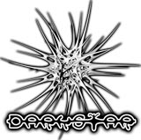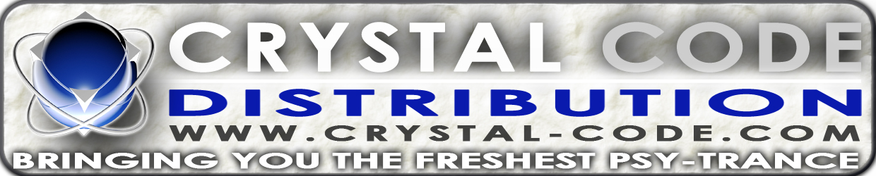
Title: | DIGITAL DRUGS: DOUBLE THE DOSE
Artist: | v/a compiled by Dr. Spook
Label: | DARKSTAR / Geomagnetic.tv
Catalogue: | GEOCD016
Format: | 6-Panel Digipak Audio 2CD
Barcode: | 9366977745230
Release: | October 2006 World Wide
TRACK LIST
1. ELECTRYPNOSE – Let The Games Begin
2. SHAPESTATIC – Headroom
3 DAI aka AMATTI – Eraser Head
4. FACEHEAD – Mission_Statement
5. PRIMORDIAL OOZE – Taking You Away
6. . WICKED WIRES vs BRAIN HUNTERS – Prescribed Drugs
7. TOTAL SICKNESS vs TRAKA – Drug Addiction
8. NEUROMYTH vs ALIEN ZED - TopFreQ
9. TSABEAT – Intense Radioactive
10. ONNOMON – War Onno Drugs
11. ARABALI (MUBALI vs ARAHAT) – Lunar Freqs
12. TRICOSSOMA – Voices from Darkness
13. NEUROMYTH – Angry Labs
14. DARKFORCE – Two Towers
15. K_LAPSO - Ciclosporina
16. BUS (GUS TILL) – Bagdad Plasma
17. PSYCHOZ – Termology (RMX)
18. SPIRAL – Idiotic Legion
19. THE GORGON – Mutilated Brain Weeps Upon A Dying Soul
20. DISTORTED GOBLIN – Doctor Of Sound 21. AIRI vs FABIUZ – SNACK SHOP

CREDITS
Mastered by Chromatone Waveworks
Engineering by Random
Artwork by Doctor Spook
Distribution by Saiko Sounds
(p) and © Geomagnetic.tv
http://geomagnetic.tv/releases/DigitalDrugs.htm
info@geomagnetic.tv Hi-Res art online.

