Skyloops – Insane, [DIGICD012] Digital Drugs Coalition/MORNINGSTAR /Geomagnetic.tv

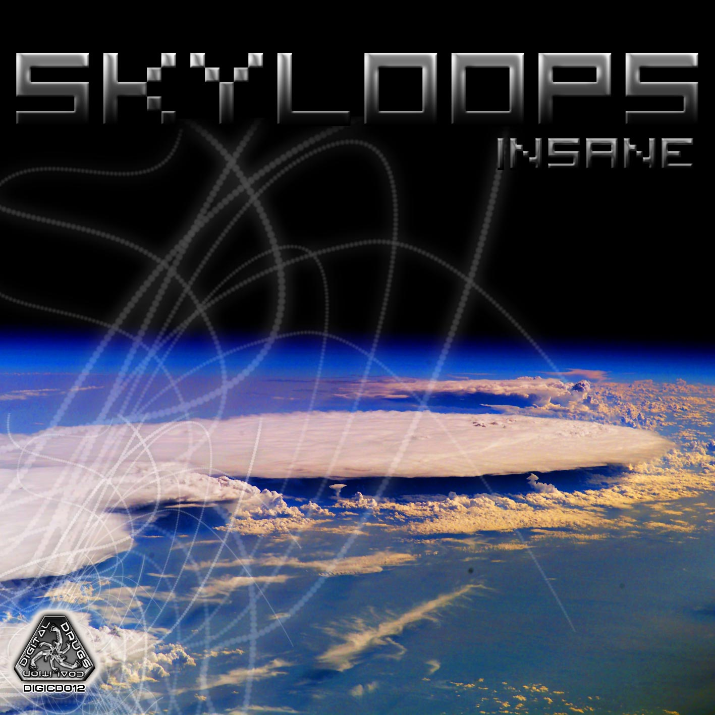 |  | RELEASE NOTES  Skyloops – Insane, [DIGICD012]  Get ready to go “Insane” as you enjoy the debut album from Skyloops, the psychedelic trance project of Sebastian Strazza and Mariana Zarankin from Buenos Aires, Argentina. Expect a hybrid sound of dirty retro electro goa pumped up with hard raspy acid techno and drenched with layers of psychedelic trance. They give us a full range of sounds and a full range of beats per minute pushing the edge of the morning full on genre into 155 bpp! But wait! Its not hard dark wacky psy instead prepare for a new genre defying leap into the stratosphere and beyond and you are propelled into orbit wizzing by satellites and aliens! Skyloops dynamic duo are both musicians since the age of 14 years old, they meet each other at beginning of 2000 and since then where involve in different projects and the psychedelic music get into their minds. At the end of 2004 Sebastian starts his carer as a dj playing with artists like Sesto Sento, Cycle Sphere, Ferbi Boys, Analog Pussy, Azax Syndrom, Rinkadink, System Nypel, Electro Sun, Chromossome, Andromeda, Alternative Control, Zen Mechanics, Altom, etc; and with Mariana start to produce psytrance parties called Under Attack. Later the feeling for music get so strong that they start to produce psychedelic music and with this new project they are making their dream come true, the dream of express what is in their souls. On 2008 Skyloops has joined Geomagnetic . We will see the things that this couple is going to give us!  Artist Profile: www.myspace.com/skyloopsmusic  Skyloops is the psychedelic trance project of Sebastian Strazza (26 years old) and Mariana Zarankin (25 years old) from Buenos Aires, Argentina. They are both musicians since the age of 14 years old, they meet each other at beginning of 2000 and since then where involve in different projects and the psychedelic music get into their minds. At the end of 2004 Sebastian starts his carer as a dj playing with artists like Sesto Sento, Cycle Sphere, Ferbi Boys, Analog Pussy, Azax Syndrom, Rinkadink, System Nypel, Electro Sun, Chromossome, Andromeda, Alternative Control, Zen Mechanics, Altom, etc; and with Mariana start to produce psytrance parties called Under Attack. Later the feeling for music get so strong that they start to produce psychedelic music and with this new project they are making their dream come true, the dream of express what is in their souls. On 2008 Skyloops has joined Geomagnetic . We will see the things that this couple is going to give us!  Label Profile: www.myspace.com/geomagnetic  Digital Drugs Coalition is a union of psychedelic trance artists from around the globe who believe that digital art + music are the purest form of getting high. Expect unique, fresh + truly out of this world productions from this hot posse!! www.myspace.com/digitaldrugscoalition  Morningstar, division of Geomagnetic Records. Uplifting, melodic, full-on, progressive and perfect for those ecstatic moments of sunshine and awakening, we know you want to be carried on a cloud of feel-good grooviness as you welcome the morning light!  Geomagnetic.tv was established in the summer of 2001 by Dr. Spook one of the founders of the prominent San Francisco 3D FX and Multimedia boutique known as Minds Eye Media (est.1995). www.mindseyemedia.com
Title: | Skyloops – Insane
Artist: | Skyloops
Label: | Digital Drugs Coalition
Catalogue: | DIGICD012
Format: | 4-Panel Insert/Tray Jewel CD
Barcode: | 881034279156
Release: | January 2009 World Wide
TRACK LIST

01-Intro
02-Roll Out
03-Uncensored
04-Computers
05-Modern Stimulation
06-Life Out There
07-One Hundred Million Stars
08-Evolution
09-Let's Go
10-We Are Connected
11-Outro
-----------------------------------------------
CREDITS
Artwork by Nathan Vogel aka Dr. Spook
Distribution by Saiko Sounds & Psyshop
(p) and © www.Geomagnetic.tv
http://www.geomagnetic.tv/labels/DigitalDrugs/DIGICD012-Skyloops/ info@geomagnetic.tv
